

**Analyzing Fake News on Social Media**



# Project Associates

M.Anjali(20481A04E5)

M.Sai Rishwanth(20481A04E3)

M.Priyanka(20481A04C9)

M.Kavya Reddy(20481A04D1)

|  |  |
| --- | --- |
| **Table Of Contents**  **S.No Topic** | **PageNo** |
| 1. Introduction    1. Overview    2. Purpose | 3 |
| 1. Literature Survey    1. Existing Problem    2. Proposed Solution | 4 |
| 1. Theoritical Analysis    1. Block diagram    2. Hardware/Software Designing | 4 |
| 4. Experimental Investigations | 5 |
| 5. Flowchart | 14 |
| 6. Result | 14 |
| 7. Advantages & Disadvantages | 15 |
| 8. Applications | 16 |
| 9. Conclusion | 16 |
| 10. Future Scope | 17 |

# 1.Introduction

**1.1 Overview**

Fake news is false or misleading information presented as news.Nowadays, fake news has become a common trend. Even trusted media houses are known to spread fake news and are losing their credibility.



The rapid spread of fake news has become a major issue worldwide. The spread of false and misleading news has led to significant social and economic consequences, impacting industries from finance to healthcare. For example, in 2020, during the COVID-19 pandemic, several countries witnessed a spike in false news about the virus, leading to confusion and panic among people. Misinformation and fake news can have a long-term impact, especially when people rely on accurate information to make critical decisions. The need for detecting fake news has never been more crucial. Machine learning techniques can help us detect fake news efficiently and accurately. Using natural language processing techniques, machine learning algorithms can accurately detect and categorize true and false news. ML systems may distinguish between true news and false news by analyzing patterns in the language and sources used in news reports.

In this project, we have built a classifier model that can identify news as real or fake. For this purpose, we have used data from Kaggle, but you can use any data to build this model following the same methods.With the help of this project, you can create an NLP classifier to detect whether the news is real or fake.

**1.2Purpose**

Once you complete this project you will be able to gain

* Knowledge on Machine Learning Algorithms.
* Knowledge on Python Language with Machine Learning.
* Knowledge on Statistics and Graphs and their relations.
* Knowledge on Natural Language Processing (NLP).
* Real Time Analysis of Project.
* Building an ease of User Interface (UI).
* Navigation of ideas towards other projects(creativeness).
* Knowledge on building ML Model.
* You will be able to know how to find the accuracy of the model.
* How to Build web applications using the Flask framework.

## 2. Literature Survey

**2.1 Existing Problem**

In the existing systems for detecting fake news, several approaches and techniques have been used, including manual fact-checking, crowd-sourced fact-checking, and automated or semi-automated.

* Manual Fact-Checking: This traditional approach involves human experts analyzing news content to determine its veracity. However, given the vast amount of content generated daily, this is a slow, resource-intensive process and is not scalable.
* Crowdsourced Fact-Checking: This approach leverages the power of the crowd to verify the authenticity of information. Platforms like Wikipedia and Snopes involve a community of users who collaborate to verify facts in content.

However, it can also be time-consuming and susceptible to bias or manipulation.

**2.2 Proposed Solution**

Machine Learning Techniques have shown promising results in detecting fake news with the help of analyzing vast amounts of data, in which it identifies patterns and it provides outcomes that are based on those patterns. Machine Learning can be applied in various ways and fields for the detection of false information.

In this project a model is build based on the count vectorizer or a tf-idf matrix (i.e word tallies relatives to how often they are used in other artices in your dataset) can help . Since this problem is a kind of text classification, Implementing a Naive Bayes classifier will be best as this is standard for text-based processing. The actual goal is in developing a model which was the text transformation (count vectorizer vs tf-idf vectorizer) and choosing which type of text to use (headlines vs full text).

## 3. Theoritical Analysis

**3.1 Block diagram**

The following block diagram gives the overview of the project.The information is taken through a web page which is created using flask framework. It then checks whether the information is fake or real using a Machine Learning algorithm.

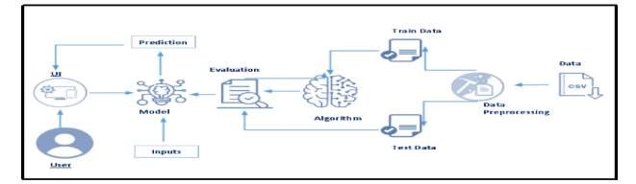

**System Architecture**

**3.2 Hardware/Software Designing Hardware Requirements :**

**Processor** : i3

**RAM** : 4GB

**Hard Disk** : 1TB

**Software Requirements :**

|  |  |
| --- | --- |
| **Operating System** | : Windows |
| **Coding Language** | : Python |

**Flask Framework :**

• To build this flask application you should have basic knowledge of “HTML, CSS, Bootstrap, flask framework and python”.

# 4.Experimental Investigations

➢**Project Flow**

* User interacts with the UI (User Interface) to give the review as input
* Given Review is analyzed by the model which is integrated to UI build
* Once model analyses the review the prediction is showcased on the UI To accomplish this, we have to complete all the activities and tasks listed below
* Install required packages and libraries.
* Install packages and libraries.
* Install Anaconda software.
* Run Jupyter
* Understanding the data.
* Download the dataset.
* Importing the required libraries.
* Loading the dataset.
* Countvectorizer for text classification.
* TF-IDF Vectorizer for text classification.
* Inspecting the vectors.
* Model Building
* Splitting the data into train and test.
* Training and testing the model with Countvectorizer & Predicting the result.
* Training and testing the model with TF-IDF Vectorizer & Predicting the result.
* Improving the model.
* Inspecting the model.
* Saving the model
* Application Building
* Flask Structure
* Importing libraries
* Load Flask and Assign the model.
* Routing to the Html page.
* Run the app in local browser.
* Final UI
* Input the URL & get the result.
* **Project Structure**

Create a Project folder that contains files as shown below

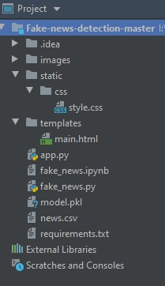

* + We are building a Flask Application which needs HTML pages “**main.html**” stored in the templates folder and a python script **app.py** for server side scripting
  + The model is built in the notebook **fake_news.ipynb**o We need the model which is saved and the saved model in this content is **model.pkl**. o The static folder will contain a css file which is used in the html file. o The templates mainly used here are “**main.html**” for showcasing the UI o The flask app is denoted as **app.py**.
* **Data Collection & Preparation:-**

There are many popular open sources for collecting the data. Eg: kaggle.com, UCI repository, etc. In this project we have used .csv data. This data is downloaded from kaggle.com.As the dataset is downloaded. Let us read and understand the data properly with the help of some visualisation techniques and some analysing techniques.

**Note:** There are a number of techniques for understanding the data. But here we have used some of it. In an additional way, you can use multiple techniques.

❖**Import the libraries given in the below image**

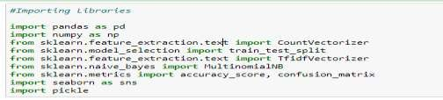

**Numpy**- It is an open-source numerical Python library. It contains a multi-dimensional array and matrix data structures. It can be used to perform mathematical operations on arrays such as trigonometric, statistical, and algebraic routines. Pandas objects are very much dependent on NumPy objects.

**Pandas**- It is a fast, powerful, flexible, and easy-to-use open-source data analysis and manipulation tool, built on top of the Python programming language.

**Seaborn**- Seaborn is a library that uses Matplotlib underneath to plot graphs. It will be used to visualize random distributions.

**Count-Vectorizer**- Scikit-learn’s CountVectorizer is used to convert a collection of text documents to a vector of term/token counts. It also enables the pre-processing of text data prior to generating the vector representation. This functionality makes it a highly flexible feature representation module for text.

**TF-IDF Vectorizer** - TF-IDF is an abbreviation for Term Frequency Inverse Document Frequency. This is very common algorithm to transform text into a meaningful representation of numbers which is used to fit machine algorithm for prediction.

**Loading The Dataset**

Here, we are reading the dataset(.csv) from the system using pandas and storing it in a variable ‘df’. It's time to begin building your text classifier! The data has been loaded into a DataFrame called df. The .head() method is particularly informative.

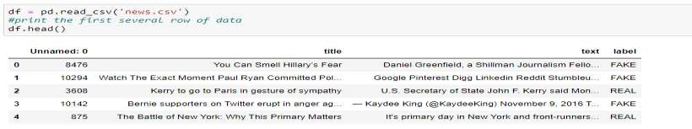

You can see your data set has three columns: title, text, and label. We make use of Text and label columns to build the classifier.

* **CountVectorizer**

**Building word count vectors with scikit-learn CountVectorizer for text classification.**

Now, we’ll use pandas alongside scikit-learn to create a sparse text vectorizer. We can use it to train and test a simple supervised model. To begin, you'll set up a CountVectorizer and learn some of its features.

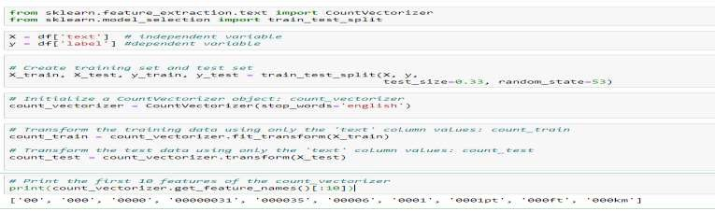

* **Tfidf Vectorizer For Text Classification**

Similar to the sparse CountVectorizer created in the previous step, we’ll work on creating tf-idf vectors for your documents. You'll set up a TfidfVectorizer and learn some of its features.

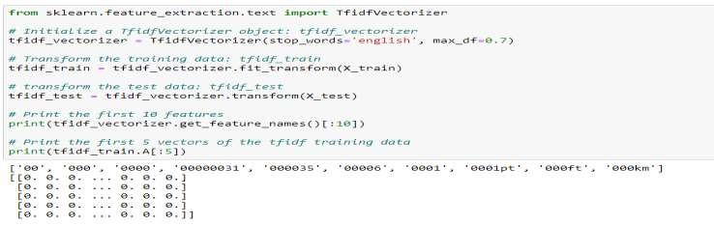

* **Inspecting The Vectors**

To get a better idea of how the vectors work, we'll investigate them by converting them into pandas DataFrames.

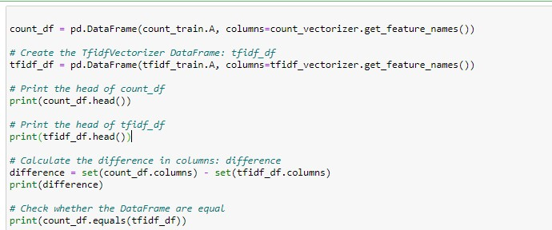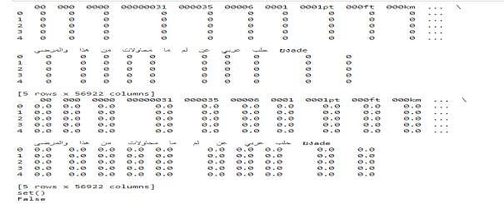

➢ **Model Building:**

❖**Splitting the data into Train and Test**

Divide the model into Train and Test data by Dependent and Independent Columns. Here in the dataset we need to separate the dependent and independent variables.

1. The independent variable in the dataset would be considered as 'x'
2. The dependent variable in the dataset would be considered as 'y'

Then we will split the data of independent and dependent variables.

Basically, as we know splitting of data is done to separate training and testing values to train and test the model. The percentage of splitting would be ideal when we take 67% of train data and 33% of test data to give it to the model.

Let's split the data into train and test by using Scikit learn as a package and then split the data as shown below.

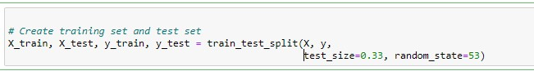

* + **Training And Testing A Classification Model With Scikit-Learn**

Training and testing the "fake news" model with CountVectorizer.Now we need to train the "fake news" model using the features you identified and extracted. Firstly we'll train and test a Naive Bayes model using the CountVectorizer data.

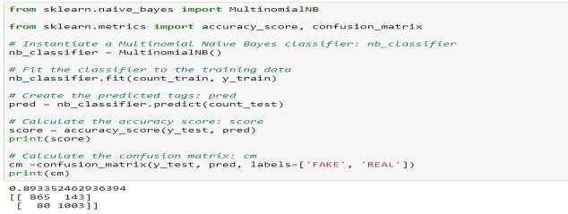

Show the confusion matrix and accuracy score for the model on the test data

The output is meaningful but looks like absolute garbage. So, we can make it beautiful with a heatmap from the Seaborn library for plotting the confusion matrix for the count vectorizer.

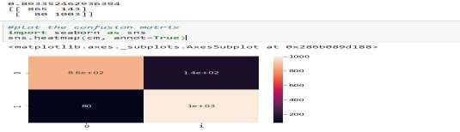

* + **Training And Testing The "Fake News" Model With TfidfVectorizer**

Now that we have evaluated the model using the CountVectorizer, we'll do the same using the TfidfVectorizer with a Naive Bayes model.

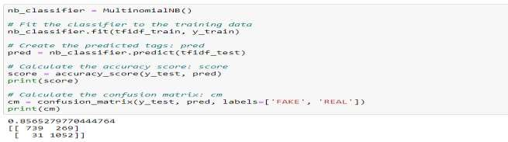

Show the confusion matrix and accuracy score for the model on the test data

The output is meaningful, but looks like absolute garbage. So, we can make it beautiful with a heatmap from the Seaborn library for plotting the confusion matrix for TF-IDF vectorizer.

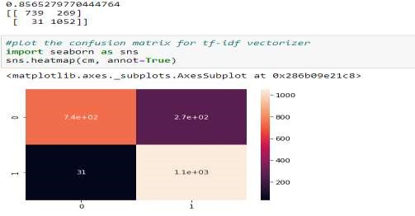

* + **Simple NLP, Complex Problems**

Improving the model. Our job is to test a few different alpha levels using the Tf-Idf vectors to determine if there is a better-performing combination.

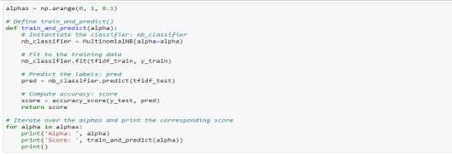

Output of Improving model:

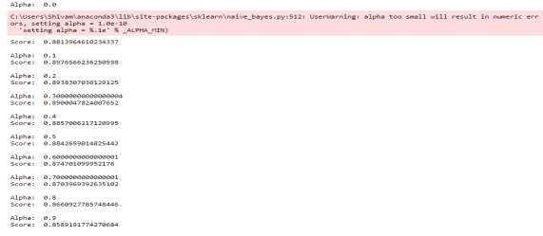

* + **Inspecting Our Model**

Now that we have built a "fake news" classifier, we’ll investigate what it has learned. We can map the important vector weights back to actual words using some simple inspection techniques.

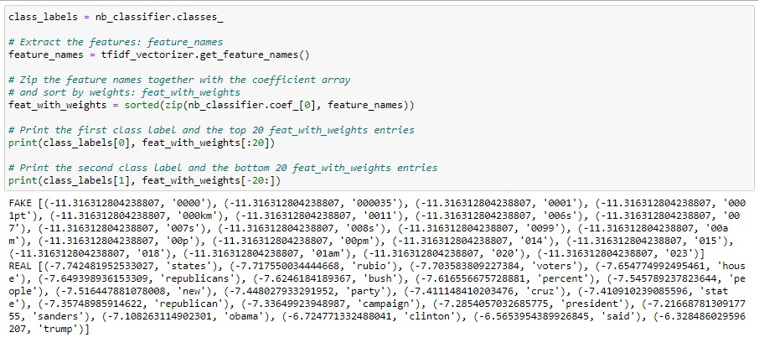

* + **Saving The Model**

After building the model we have to save the model.

Pickle in Python is primarily used in serializing and deserializing a Python object structure. In other words, it's the process of converting a Python object into a byte stream to store it in a file/database, maintain program state across sessions, or transport data over the network. wb indicates write method and rd indicates read method. This is done by the below code

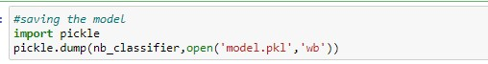

➢**Build Flask Application:-**

* **Flask Structure** 
  + To build this flask application you should have basic knowledge of “HTML, CSS, Bootstrap, flask framework and python”
  + For more information regarding[flask](https://www.tutorialspoint.com/flask/index.html)
  + **Main Python Script**• Let us build a flask file ’Fake_news.ipynb’ which is a web framework written in python for server-side scripting. Let’s see the step by step procedure for building the backend application.
  + You can also run this on spyder, given as app.py
  + App starts running when the “__name__” constructor is called in main.
  + Render_template is used to return html files.
  + “GET” method is used to take input from the user.
  + “POST” method is used to display the output to the user.
  + Main.html web pages are given.
* **Build Flask Application**

Libraries required for the app to run are to be imported.

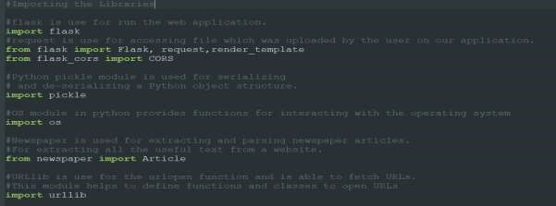

Loading Flask and assigning the model variable

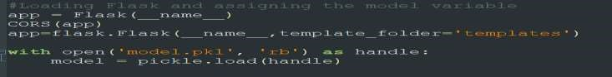

* **Routing to the html Page**

Basically we give routes of our html pages in order to showcase the UI. By giving the routes the built code in the html page is connected to our flask app. This is how a UI can be built and showcased.

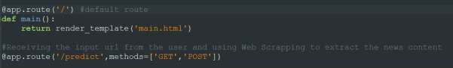

We are routing the app to the html templates which we want to render. Firstly we are rendering the “main.html” template and from there we are navigating to our prediction page.

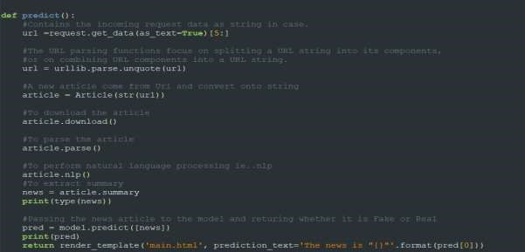

Here the route for prediction is given and necessary steps are performed in order to get the predicted output.

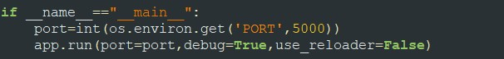

Lastly, we run our app on the local host. Here we are running it on localhost:5000

* Run The app in local browser

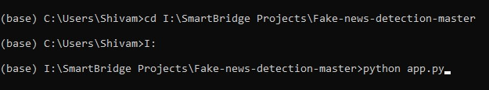

* Open anaconda prompt from the start menu
* Navigate to the folder where your python script is.
* Now type “python app.py” command
* Navigate to the localhost where you can view your web page.

# 5.FlowChart:-

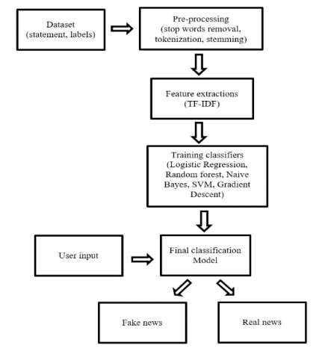

# 6.Result:-

This is the main page of Fake News Detection where we give the URL as input and predict the output.• Input the URL & predict the result.

• Paste the URL of the article and click to predict the output whether it is Fake or Real.



This article is Real based on our model.

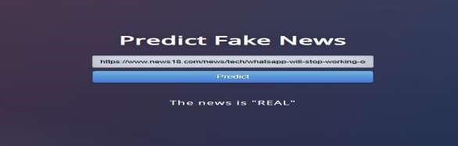

This article is Fake based on our model.



## 7. Advantages & Disadvantages

Machine learning has led to significant developments in false news detection. However, machine learning has advantages and disadvantages when detecting false news. This section will explore the pros and cons of using machine learning for false news detection.

**Advantages :**

There are several advantages of using machine learning for detecting fake news: oMachine learning algorithms are capable of swiftly and effectively analyzing massive volumes of data. Because there are so many news articles published every day, it is impossible for humans to manually analyze every article. News outlets and social media platforms can easily identify false news because of machine learning algorithms' ability to handle massive volumes of data quickly. oAlgorithms that use machine learning can find links and patterns in data that may not be obvious to people. Machine learning algorithms can precisely identify fake news stories by examining the wording, sources, and social media networks linked to news pieces. oIn order to stop the spread of incorrect information, social media platforms and news organizations can immediately take action thanks to machine learning algorithms' ability to identify fake news stories in real-time. The process of identifying false news stories may be automated with machine learning algorithms. Humans will have less work to do, as a result, freeing them up to work on things like fact-checking and investigative journalism. oThe detection of false news stories may be done at a reasonable price using machine learning algorithms. Once taught, the algorithms may be widely used without incurring a lot of expense.

**Disadvantages :**

Fake news detection using machine learning has its disadvantages as well o Machine Learning algorithms are only on the data that they are trained on. If the dataset is biased, so will the algorithm. So we need to keep in mind that we have to consider the randomness of the datasets that contain news articles from various sources.

* Machine learning techniques are capable of identifying fake news, but they are not entirely reliable, as there is always a possibility of misidentification of true news as fake and vice versa. Therefore we need to consider multiple strategies, such as factchecking, which are necessary to evaluate the authenticity of the news.

# 8.Application:-

The solution for fake news detection using machine learning and natural language processing techniques can be applied in various areas:

* **Media and Journalism**: News agencies can use this technology to verify the authenticity of the news before publishing, thereby maintaining their credibility and trust among readers.
* **Social Media Platforms**: Fake news often spreads rapidly on social media. Implementing a fake news detection system can help these platforms identify and remove false information, leading to a more accurate and reliable online environment.
* **Government and Public Sector**: Government agencies can use these models to combat misinformation in the public domain, particularly during critical times like elections or public health crises.
* **Education**: Educational institutions can use this technology to teach students about media literacy and the importance of verifying information.

## 9. Conclusion:-

This project demonstrated how machine learning and natural language processing can effectively detect fake news. A classifier model was built using a count vectorizer, a tf-idf matrix, and a Naive Bayes classifier. Despite certain limitations such as potential bias and the need for updates, the model proved efficient in analyzing large data volumes. The project emphasized the importance of combining technology with other strategies like fact-checking to ensure news accuracy. While machine learning is a significant contributor to fake news detection, human judgment remains key.

# 10.Future Scope:-

The future scope of this project on fake news detection using machine learning and natural language processing could include:

* **Improved Models:** Advances in machine learning and natural language processing could lead to the development of more accurate and efficient models for detecting fake news.
* **Multilingual Support**: The current project is likely based on English language data. In the future, the model could be expanded to support multiple languages, making it more globally applicable.
* **Image and Video Analysis:** As fake news often involves misleading images and videos, future work could involve extending the model to analyze visual content for a more comprehensive approach to fake news detection.